**Making Marks in Cold Wax Workshop Supply List**

**The Creativity Curator**

**Questions or more information contact:**

**Jacqueline Burke Volpe thecreativitycurator@gmail.com thecreativitycurator.com**

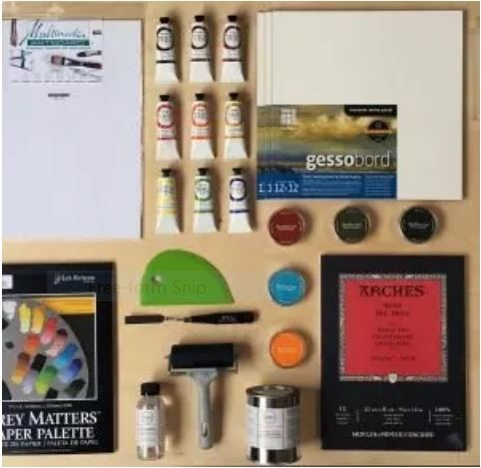**If you have all these items or something similar - that is good, if not experiment with what you have. Items marked with an asterisk and highlighted in yellow are the basic required supplies to work in cold wax.**

**\* Included in the kit: cold wax medium, oil paint, oil paper.**

**± You provide in addition to the contents of your kit you need to provide these items: paint remover/cleaner, brayer, squeegee, tape, tools to make marks and textures, palette, paper towels. You may be able to improvise, if you don’t have a tool, we can discuss it during the workshop.**

**\*± If you did not receive a kit, you need to gather the items highlighted below in both yellow and blue. A wood panel can be substituted for the oil paper. Cold wax is available at local craft stores and on-line.**

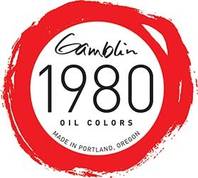**All other items are optional. They are for experimentation.**

**You can participate without a kit.**

▪ **Cold Wax Medium** I prefer Gamblin. A small amount goes a long way, so 12 ounces is enough. Dorland is another cold wax brand.

▪ **\* Oil paint. We will be using oil paint not acrylic – this process is not done with acrylics.**

Use your favorite oil paint or whatever oil paint you already have, it can be transparent, opaque, dark, light, warm, or cool colors. You can experiment with house oil paint.

If you mix your own colors, you may need less paint – i.e. you use primary colors to mix colors. Included in the kit are white, black, and pre-mixed colors.

Put together a basic palette of your favorite oil paints -- I will be using Gamblin 1980, Gamblin’s student grade line of paints. Craft stores have frequent sales or offer coupons. Ocean State Job Lot is another useful source for art supplies.

▪ A basic palette of oil colors might include some of the following colors:

▪ Titanium white

▪ Phthalo blue or Ultramarine blue

▪ A transparent orange

▪ A transparent red

▪ A transparent earth color

▪ Sap green

▪ Cadmium yellow

▪ Cadmium red

▪ Cadmium orange

▪ Ivory black

▪ Earth colors (yellow ochre, siennas, umbers, Asphaltum)

Water-soluble oil paints are fine but are not more advantageous than regular oil paints.

▪ **Substrate – the surface on which you will paint.**

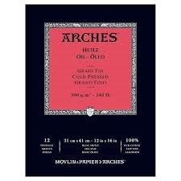**\*Oil Paper**, 9x12 inches or larger. Two or more sheets. I use Arches oil paper. Swarthmore oil paper is another option. Arches Oil Paper and Multimedia Artboard do NOT need any preparation prior to use.

**Painting Panels. Wood.** Sizes: 11x14, 12x12, 12x16, 16x16, or 16x20 inches. We will not be using these in the workshop. But, feel free to provide your own. As you progress with this technique you may wish

to give painting on another substrate a try. You must gesso wood panels with acrylic gesso before using OR use prepared panels such as Gessobord, Encausticbord, or Claybord by Ampersand. I like to use cradled birch facing panels. They are available unprimed and primed. Two sources I use are Dick Blick and Arteza. Gamblin makes a Ground is thicker than acrylic gesso and require less coats. https://gamblincolors.com/oil-painting/sizes-and-grounds/

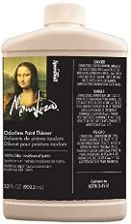**Primed linen / canvas panels** are not used since adhesion on these can be problematic.

▪ **± Paint Remover/Cleaner.** For clean up mostly but can also be used for special effects. Alternatives to Mineral Spirits: Citra-Solv degreaser, baby oil, vegetable oil, mineral oil, odorless paint thinner such as Mona Lisa or Gamsol.

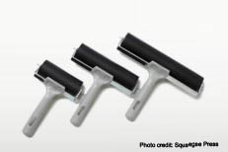▪ **± Soft brayer.** Brayers are made from various materials and are soft or hard. I will be using a 2 inch and 4-inch soft brayer. Brayers come in multiple sizes: 2, 4, 6 and larger. For starting out I recommend a 4-inch brayer.

Chose a soft rubber brayer that has some give - is not too hard. I use brayers sold by the Squeegee Press.Other brands:Inovart Pro, Speedball, Gelli Art Print. The Speedball and Gelli Art, which are used when printmaking, are too firm for most techniques, but if that is what you have try it before buying new.

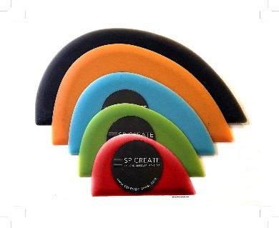Improvise with a non-absorbent cylinder.

▪ **± Squeegee.** Squeegees come in varied materials and in multiple sizes. Common sizes are 2, 4, 6, 9 and larger. In the workshop I will be using a 2 inch and 4-inch squeegee. To get started I recommend a 4-inch squeegee.

Improvise with a credit card or a kitchen bowl scraper.

▪ **± Palette knife.** I like to use knives with offset handles.

Improvise with an offset cake icing spatula or dinner /butter knife.

|  |  |
| --- | --- |
|  |  |
| ▪ | **± Repositionable Tape: 1 inch stencil tape or painter’s tape.** |
| ▪ | **± Materials to create marks and textures.** Artist’s choice – these are your individual choice. Examples: paper, carving tools, stylus, palette knife, charcoal, dirt, sand, markers (sharpies), charcoal, etc.. |
| ▪ | **± Disposable palette** - wax paper, parchment, deli sheets, tracing paper, or another non-porous surface. I use a sheet of wax paper, palette paper, or plexi-glass for a palette. To preserve my palette in between session, I cover it with plastic. |
| ▪ | **± Paper towels** or other disposable cloths. I like to use shop cloths that I get at the auto supply store and rumple cloth. You can also use an old t-shirt or nylons. |

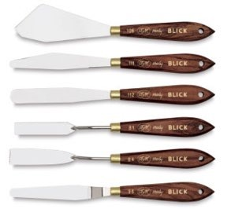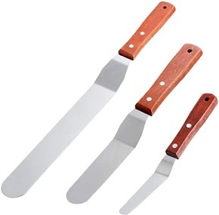

**OPTIONAL ITEMS:**

▪ **Gloves** – if you use them

▪ **Brushes.** These are not necessary for the workshop; I do not use them for this technique.

▪ **Pigment sticks.** These are made by mixing oil paint with wax for the paint to be molded into stick form. They can be used to draw or paint directly onto a surface without brushes, palettes, paint tubes, or solvents. Think of them as oil in stick form. Some contain other ingredients such as linseed oil. Manufacturers are R&F, Sennelier, Winsor & Newton, and Shiva.

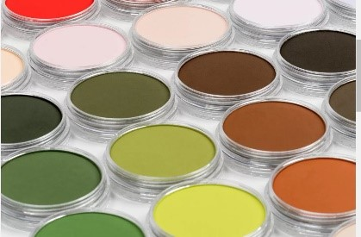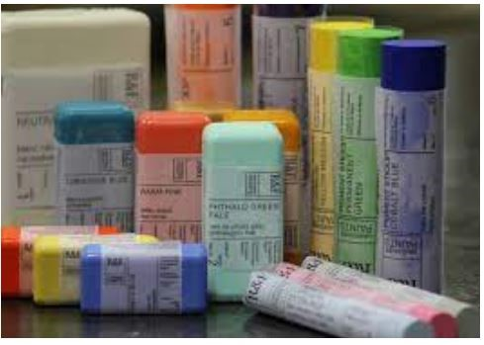

▪ **Pigment Powder or Pan Pastels.**

Pan Pastels are soft pastel pigment colors shaped like cakes. Used wet or dry, they can be mixed and applied like paint. They are different from oil pastels.

Pigments powders are what manufacturers use to give paint its color. They can be mixed with binders for painting.

▪ **Various papers** come in very handy for clean-up, brayer cleaning when switching colors, and texturizing: tissue paper, newsprint, parchment paper.

**WORK SPACE – YOUR CREATIVE SPACE:** Set up a flat area to create that is well lit and comfortable (we will do a short meditation before we start to create, participation is optional). Kitchen tables work well. You will need an area where you can place your sheet(s) of oiled paper alongside your paint palette. And some wiggle room for your tools. Don’t forget to get settled-in too with a cup of tea or a glass of wine, etc..

**RESOURCES:**

Powdered pigment: https://www.earthpigments.com/

Pan Pastels: https://panpastel.com/colors.html

Gamblin oil paint and mediums: https://gamblincolors.com/gamblin/

R&F paint sticks: https://www.rfpaints.com/

Sennlier paint sticks, oil paints: http://www.sennelier-colors.com/

Squeegee Press brayers and squeegees: <https://coldwaxacademy.com/squeegees/>

Art supply stores: Michael’s, Jerry’s Artarama, Hobby Lobby, Joanne’s Fabrics, Dick Blick, RISD student store, Ocean State Job Lot.

**Steps to cleaning your brayer, squeegee, palette knives, texture and mark making tools.**

When referring to solvent, I am not referring to a chemical, but a liquid that will dissolve/remove paint from your tools. The solvent can be oil, any type of oil (murphy’s oil soap, mineral oil, baby oil, food grade oil (vegetable oil, nut oil, safflower, even olive oil – whatever is the least expensive), or degreaser.

1. Get rid of excess paint – you can wipe it off, but better yet deposit it onto another sheet of paper and then use it for collages, wrapping, etc..
2. Place a little solvent on a non-porous surface. I spray a little citra-solv degreaser on my palette, or on a sheet of wax paper or deli sheet. I keep a spray bottle of diluted citra-solv near my work space.
3. Roll your brayer in the solvent. Let it sit to allow the solvent to do its job. Then roll it in the solvent again. Then wipe off the dissolved paint. Use the same solvent to dissolve and wipe off the paint on the squeegee. I use rumple cloth to clean my tools, but you can also use shop towels or regular paper towels or old rag.
4. Repeat these steps as needed.
5. After wiping off the solvent and dissolved paint, if desired, you can wash the items with soap and water. I usually just wipe them.

You can use the same method to clean your brushes.

It is best not to let your tools sit covered in paint overnight (or for hours) since when you try to clean off the dried paint you might damage the tool.