**BEESWAX & INK TRANSFERS WORKSHOP**

**The Creativity Curator**

**KITCHEN TABLE ART WORKSHOP**

**Contact: Jacqueline Burke Volpe**

**thecreativitycurator@gmail.com**

**thecreativitycurator.com**

**Workshop sponsored by the Medway Cultural Council**

**Tuesday, December 8, 2020 at 7:30 PM**

**On Zoom by invitation**

**WORKSPACE:**

Set up a comfortable, well-lit, solid work area.

**TOOLS & MATERIALS IN YOUR KIT:**

Beeswaxed wood panels

Magazine paper (see below to also provide your own.)

Fine sandpaper

Top / Finish coat Minwax polyacrylic.

**PLEASE GATHER THE FOLLOWING SUPPLIES TO COMPLIMENT YOUR KIT:**

1. One or more magazine(s) to cut out shapes – one magazine goes a long way. It must be one that has been printed with a special ink. High gloss, smooth paged magazines that are known for their vivid color photography work best, such as decorating and fashion magazines. Architectural Digest (most reliable), National Geographic (magazines post 2000); Martha Stewart Living; Bon Appetit; Sunday NY Times, Vogue, to name a few. I am supplying some magazine paper pieces, but you may need more, and most of all and I’d like you to have the opportunity to pick out your own colors and patterns.
2. Old credit card or thin metal scraper. *
3. Pencil.
4. Craft utility knife.
5. Cutting mat or surface.
6. Scissors.
7. Burnishing tool such as a metal spoon and/or bone folder.*
8. Small spray water bottle or small sponge/cloth and bowl/cup of water for dipping.
9. Old cotton rag like a T-shirt – small piece.
10. Pointed object to make marks (etc) in the wax, such as, a nail, or church key type bottle opener, or needle point tool like the type used for clay pottery. *

**Optional:**

* Reposition-able tape, such as painters’ tape, but if not available, any tape will work. I find it helpful to hold paper in place while I cut it.
* Backing or mounting board.
* Embellishments: such as, paint, pastels, sharpie markers, Stabilo-All pencil <https://www.amazon.com/Stabilo-All-Pencil-8046-Black-Pack/dp/B01G7IKGU2>

It is best to do a test run first on various mediums to determine how they work with the wax and magazine ink.

* Heat (embossing) gun.

**Reference Images**

#11 Pin needle tool

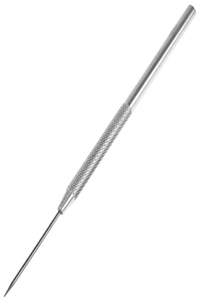

Steel kidney shaped scraper

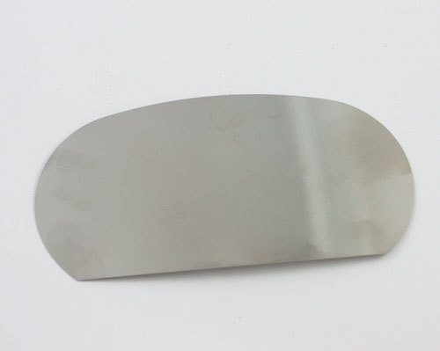

Bone Folder (Plastic)

